Nama : Ludang prasetyo Nugroho

Nim : 225510017

Praktek 1

|  |
| --- |
| #include <WiFi.h> |
| #include <WiFiClientSecure.h> |
| #include <UniversalTelegramBot.h> |
|  |
| // Wifi network station credentials |
| #define WIFI_SSID "RPLA_2.4" |
| #define WIFI_PASSWORD "utdijogja" |
|  |
| // Telegram BOT Token (Get from Botfather) |
| #define BOT_TOKEN "7650684774:AAGob6Ye1lWLl0ZtvmRbhDjqZAoXHN9a0ik" |
|  |
| #define LED1 19 |
| #define LED2 18 |
| #define LED3 5 |
| #define LED4 17 |
|  |
| const unsigned long BOT_MTBS = 1000; // mean time between scan messages |
|  |
| WiFiClientSecure secured_client; |
| UniversalTelegramBot bot(BOT_TOKEN, secured_client); |
| unsigned long bot_lasttime; // last time messages' scan has been done |
|  |
| int led1Status = 0; |
| int led2Status = 0; |
| int led3Status = 0; |
| int led4Status = 0; |
|  |
| void handleNewMessages(int numNewMessages) |
| { |
| Serial.print("handleNewMessages "); |
| Serial.println(numNewMessages); |
|  |
| for (int i = 0; i < numNewMessages; i++) |
| { |
| String chat_id = bot.messages[i].chat_id; |
| String text = bot.messages[i].text; |
|  |
| String from_name = bot.messages[i].from_name; |
| if (from_name == "") |
| from_name = "Guest"; |
|  |
| // Commands for LED 1 |
| if (text == "/led1on") |
| { |
| digitalWrite(LED1, HIGH); |
| led1Status = 1; |
| bot.sendMessage(chat_id, "Led1 ON", ""); |
| } |
| if (text == "/led1off") |
| { |
| digitalWrite(LED1, LOW); |
| led1Status = 0; |
| bot.sendMessage(chat_id, "Led1 OFF", ""); |
| } |
|  |
| // Commands for LED 2 |
| if (text == "/led2on") |
| { |
| digitalWrite(LED2, HIGH); |
| led2Status = 1; |
| bot.sendMessage(chat_id, "Led2 ON", ""); |
| } |
| if (text == "/led2off") |
| { |
| digitalWrite(LED2, LOW); |
| led2Status = 0; |
| bot.sendMessage(chat_id, "Led2 OFF", ""); |
| } |
|  |
| // Commands for LED 3 |
| if (text == "/led3on") |
| { |
| digitalWrite(LED3, HIGH); |
| led3Status = 1; |
| bot.sendMessage(chat_id, "Led3 ON", ""); |
| } |
| if (text == "/led3off") |
| { |
| digitalWrite(LED3, LOW); |
| led3Status = 0; |
| bot.sendMessage(chat_id, "Led3 OFF", ""); |
| } |
|  |
| // Commands for LED 4 |
| if (text == "/led4on") |
| { |
| digitalWrite(LED4, HIGH); |
| led4Status = 1; |
| bot.sendMessage(chat_id, "Led4 ON", ""); |
| } |
| if (text == "/led4off") |
| { |
| digitalWrite(LED4, LOW); |
| led4Status = 0; |
| bot.sendMessage(chat_id, "Led4 OFF", ""); |
| } |
|  |
| if (text == "/status") |
| { |
| String statusMessage = "Status:\n"; |
| statusMessage += "Led1: " + String(led1Status ? "ON" : "OFF") + "\n"; |
| statusMessage += "Led2: " + String(led2Status ? "ON" : "OFF") + "\n"; |
| statusMessage += "Led3: " + String(led3Status ? "ON" : "OFF") + "\n"; |
| statusMessage += "Led4: " + String(led4Status ? "ON" : "OFF") + "\n"; |
| bot.sendMessage(chat_id, statusMessage, ""); |
| } |
|  |
| if (text == "/start") |
| { |
| String welcome = "Welcome to Universal Arduino Telegram Bot library, " + from_name + ".\n"; |
| welcome += "This is Flash Led Bot example.\n\n"; |
| welcome += "/led1on : to switch Led1 ON\n"; |
| welcome += "/led1off : to switch Led1 OFF\n"; |
| welcome += "/led2on : to switch Led2 ON\n"; |
| welcome += "/led2off : to switch Led2 OFF\n"; |
| welcome += "/led3on : to switch Led3 ON\n"; |
| welcome += "/led3off : to switch Led3 OFF\n"; |
| welcome += "/led4on : to switch Led4 ON\n"; |
| welcome += "/led4off : to switch Led4 OFF\n"; |
| welcome += "/status : Returns current status of all LEDs\n"; |
| bot.sendMessage(chat_id, welcome, ""); |
| } |
| } |
| } |
|  |
| void setup() |
| { |
| Serial.begin(115200); |
| Serial.println(); |
|  |
| pinMode(LED1, OUTPUT); |
| pinMode(LED2, OUTPUT); |
| pinMode(LED3, OUTPUT); |
| pinMode(LED4, OUTPUT); |
| delay(10); |
|  |
| digitalWrite(LED1, LOW); |
| digitalWrite(LED2, LOW); |
| digitalWrite(LED3, LOW); |
| digitalWrite(LED4, LOW); |
|  |
| Serial.print("Connecting to Wifi SSID "); |
| Serial.print(WIFI_SSID); |
| WiFi.begin(WIFI_SSID, WIFI_PASSWORD); |
| secured_client.setCACert(TELEGRAM_CERTIFICATE_ROOT); |
|  |
| while (WiFi.status() != WL_CONNECTED) |
| { |
| Serial.print("."); |
| delay(500); |
| } |
| Serial.print("\nWiFi connected. IP address: "); |
| Serial.println(WiFi.localIP()); |
|  |
| Serial.print("Retrieving time: "); |
| configTime(0, 0, "pool.ntp.org"); |
| time_t now = time(nullptr); |
| while (now < 24 * 3600) |
| { |
| Serial.print("."); |
| delay(100); |
| now = time(nullptr); |
| } |
| Serial.println(now); |
| } |
|  |
| void loop() |
| { |
| if (millis() - bot_lasttime > BOT_MTBS) |
| { |
| int numNewMessages = bot.getUpdates(bot.last_message_received + 1); |
|  |
| while (numNewMessages) |
| { |
| Serial.println("got response"); |
| handleNewMessages(numNewMessages); |
| numNewMessages = bot.getUpdates(bot.last_message_received + 1); |
| } |
|  |
| bot_lasttime = millis(); |
| } |
| } |

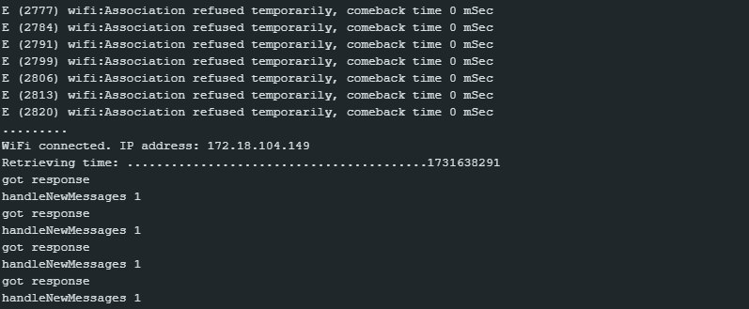

Code berjalan sesuwai arahan saat menerima pesan dari telegram akan di munculkan di serial monitor

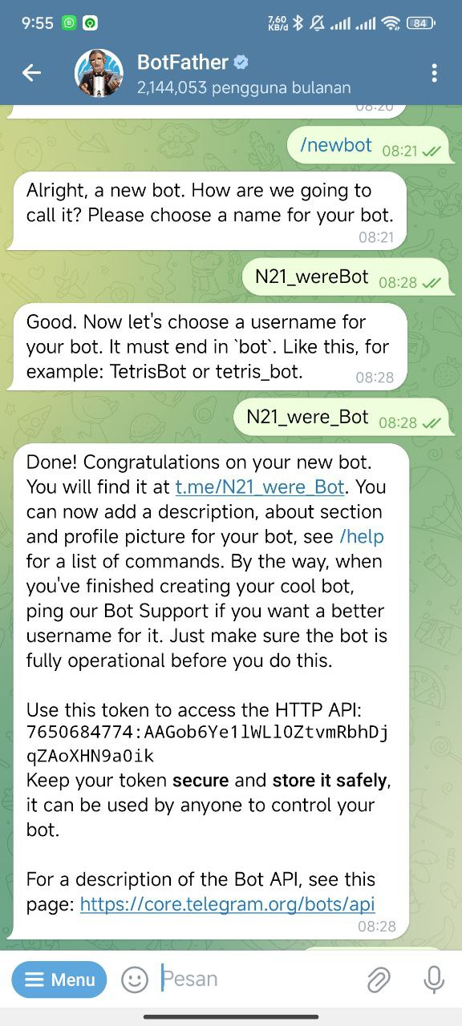

Mendapatkan token dan membuat nama bod nya

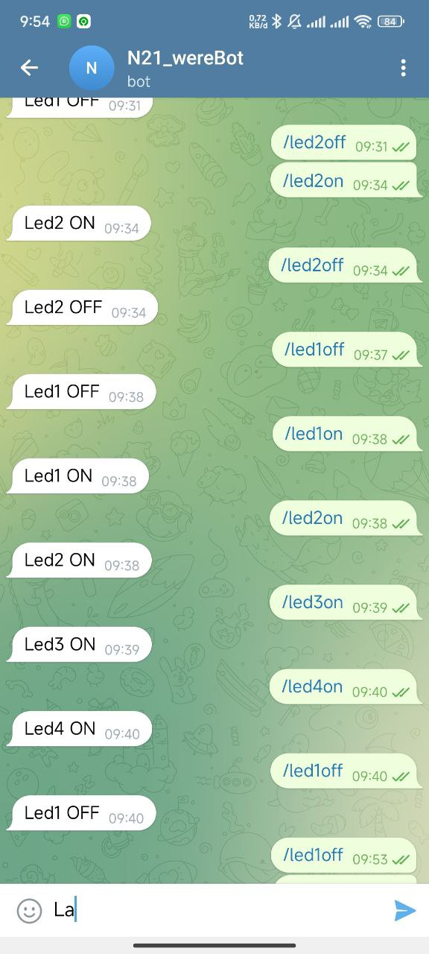

Memasukan inputan

